**MCQ QUESTIONS FOR PRACTICE**

**1) The scheme of connecting a member of computer is the form of computer called _____**

a. Network topology

b. Data topology

c. Media topology

d. All

Ans: a

**2) Backbone topology is also known as**

a. Tree topology

b. Mesh topology

c. Bus topology

d. Ring topology

Ans: c

**3) A ______Is a special device used to absorb signals..**

a. Terminator

b. Transistor

c. Motivator

d. All

Ans: a

**4) Which topology is very costly.**

a. Tree topology

b. Mesh topology

c. STAR topology

d. Ring topology

Ans: c

5)

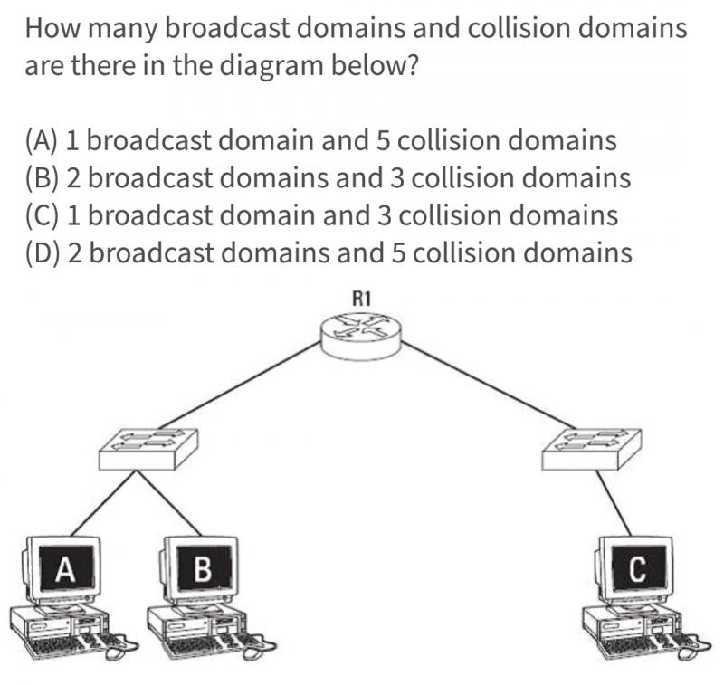

Ans: d

6) Physical Layer is Layer-1

A. Yes  
B. No  
C. Can be yes or no  
D. Can not say

Ans: a

7) The physical layer concerns with

A. bit-by-bit delivery  
B. process to process delivery  
C. application to application delivery  
D. None of the above

Ans: b

8) Bits can be send over guided and unguided media as analog signal by

A. digital modulation  
B. amplitude modulation  
C. frequency modulation  
D. phase modulation

Ans: a

9) The network layer is responsible for carrying data from one host to another.

A. TRUE  
B. FALSE  
C. Can be true or false  
D. Can not say

Ans: a

10) You want to implement a mechanism that automates the IP configuration, including IP address, subnet mask, default gateway, and DNS information. Which protocol will you use to accomplish this?

SMTP

SNMP

DHCP

ARP

Ans: c

11) What is the purpose of a checksum in data communication?

A) To encrypt data

B) To compress data

C) To detect errors in transmitted data

D) To encode data for transmission

Ans: c

12) Suppose you have a 16-bit checksum value for a data packet. How many different possible checksum values can be generated?

A) 8

B) 16

C) 32

D) 65,536

Ans: d

[A 16-bit checksum can represent 2^16 (65,536) different possible values. This allows for a wide range of unique checksums to be generated for various data packets.]

13) You are transmitting a 32-byte data packet with a 8-bit checksum. If the sum of all bytes in the packet is 250 (in decimal), what should the checksum value be for the data to be transmitted correctly without errors?

A) 255

B) 250

C) 5

D) 0

Ans: a

[ Add up all the bytes in the packet: 250.

Subtract this sum from 256 (2^8, as it's an 8-bit checksum): 256 - 250 = 6.

The checksum value should be 6 (which is 256 - 250). ]

14) Which type of checksum is typically used in the TCP (Transmission Control Protocol) header for error detection?

A) Parity checksum

B) CRC (Cyclic Redundancy Check) checksum

C) Fletcher checksum

D) Adler-32 checksum

Ans: b

15) What is the minimum Hamming distance required for a single-error-correcting code?

A) 1

B) 2

C) 3

D) 4

Ans: c

[In a single-error-correcting code, the minimum Hamming distance should be at least 3. This means that any two codewords must differ in at least three positions to allow for the correction of a single error. ]

16) You are using a (7, 4) Hamming code to encode data. How many data bits can be encoded in this code, and how many parity bits are used?

A) 3 data bits, 4 parity bits

B) 4 data bits, 3 parity bits

C) 7 data bits, 0 parity bits

D) 4 data bits, 4 parity bits

Ans: b

[In a (7, 4) Hamming code, you can encode 4 data bits, and 3 parity bits are added for error correction. The total length of the codeword is 7 bits. ]

17) If you receive a Hamming code with a single-bit error, how can you determine which bit is in error?

A) Check the parity bits.

B) Check the data bits.

C) The Hamming code cannot correct single-bit errors.

D) Compare with a reference code.

Ans: a

18) What is the minimum number of parity bits required in a Hamming code for encoding 8 data bits?

A) 1

B) 2

C) 3

D) 4

Ans: c

[

To encode 8 data bits using a Hamming code, you need to calculate the minimum number of parity bits required. The formula for the number of parity bits (m) required to encode 'n' data bits is given by:

m >= log₂(m + n + 1)

In this case, n = 8. Plugging this into the formula:

m >= log₂(8 + 8 + 1) m >= log₂(17)

Since the smallest integer greater than or equal to log₂(17) is 5, you need at least 5 parity bits. However, you want the minimum number of parity bits, so you use the smallest power of 2 greater than or equal to 5, which is 8. Therefore, you need 3 parity bits to encode 8 data bits in a Hamming code.

]